Lab1: Setting Up GNS3 v2.2.12 and Wireshark 3.2.6
Getting GNS3 and Wireshark setup properly on your personal computer system is vital in assuring the lab exercises can be completed properly. Below I included several links to videos and sites I found to be helpful in getting GNS3 downloaded, installed and setup on your computer. The videos below are for Windows 10, but additional videos are available for other common operating systems. We will be using GNS3 v2.2.12 and Wireshark 3.2.6 for this course, and following the video references are specific steps you will want to take to complete this process. We will use these programs together for some of the labs.
GNS3 2.2 Installation – Windows 10
https://youtu.be/Ibe3hgP8gCA
IOS Image Needed
http://srijit.com/working-cisco-ios-gns3/
In order to run future troubleshooting labs, using IOS version 15.x will provide the support needed for some of the more recent enhancements and technology features. For this reason, you will want to select the Cisco 7200 folder and the c7200-adventerprisek9-mz.152-4.M7.bin file. Please note where you place this on your system. This will be added once you complete the installation of GNS3 and Wireshark. The procedure below to follow with screenshots that depict what options to select for each step of the installation and setup. The examples I show below are for the GNS3 2.2.12 all-in-one installation on a Windows 10 system. This will also install Wireshark 3.2.6. Yours may vary based on specific OS, Windows version and preferences. If you have an older version already installed, you may want to save your project folders prior to proceeding with this installation.
- Download the appropriate GNS3 2.2.12 setup by going to the web site below. The newest version is available at gn3s.com/download, but we only need to get GNS3-2.2.12-all-in-one.exe.
https://gns3.com/software/download

- Run the GNS3-2.2.12-all-in-one.exe executable on your desktop and answer yes or OK to allow it to make the necessary updates to your desktop.

- Click next to continue the install.
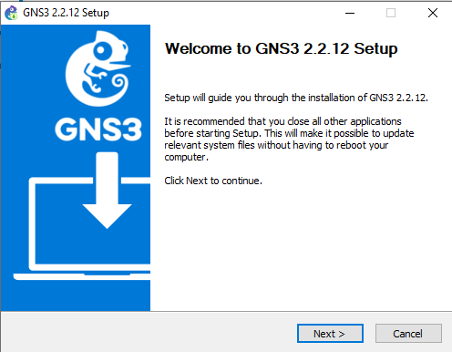

- Click “I Agree” to accept the license agreement terms.
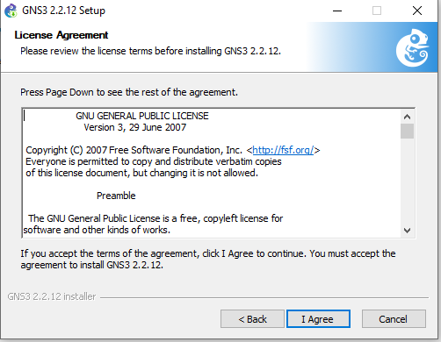
- You can simply click next to put GNS3 Start Menu and its components into the default directory chosen.
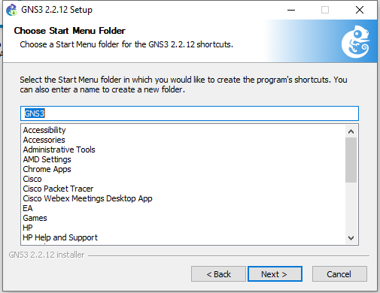

- Click Next again to put GNS3 into the default program directory for installation.
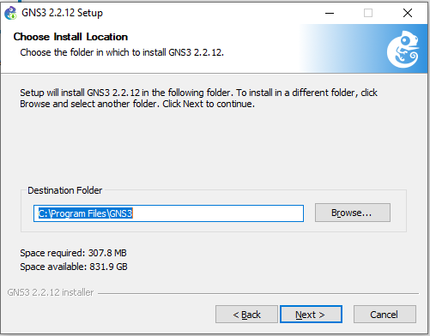
- Make sure GNS3 Desktop and Tools check boxes are both checked. This will complete the setup for each of the individual components. (If installing on a company system or laptop, please get the appropriate approvals to download and install the software. Many companies will not allow you to run the NPCAP or WinPCAP, so be aware of this and adjust accordingly. This is done by clicking on the Tools drop-down and not selecting those if applicable. This should not be necessary if this is installed onto your personal desktop.
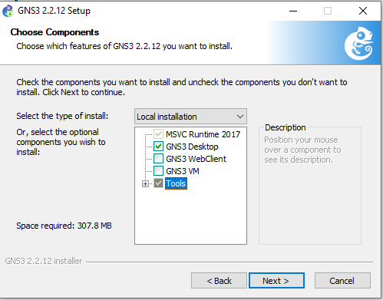

- For Npcap, you will be asked to agree to the license agreement by clicking on I Agree. 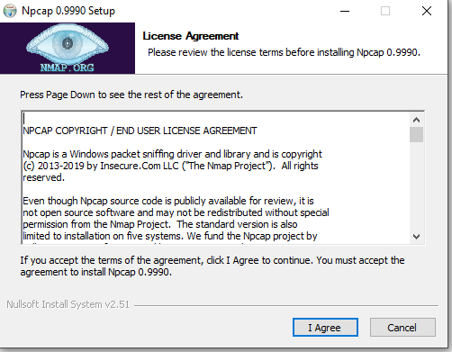

- It will then prompt you to specify installation options. Simply click Install to use the default.

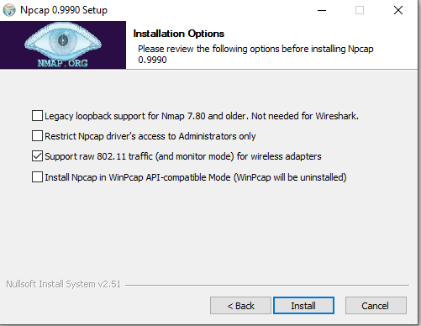

- Installation will then complete
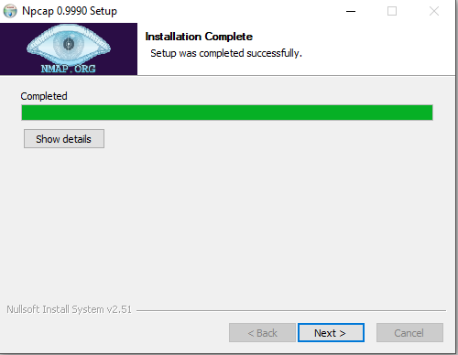
- Once Npcap is installed, it will prompt you to click Finish.
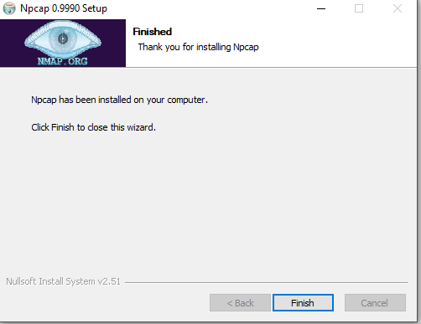

- It will then start Solarwinds tools installation.
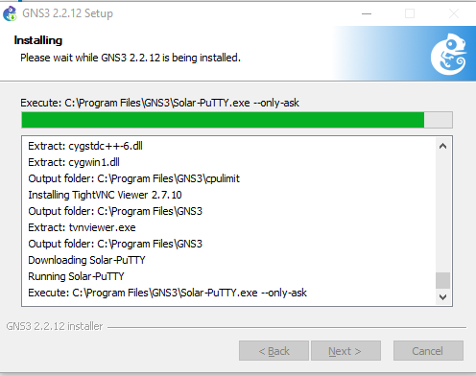
- After the installation is complete it will ask you to accept the License Agreement. Click on the I Agree check box and click Accept.
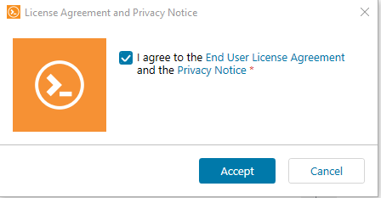
- Input your email where prompted and click Continue.

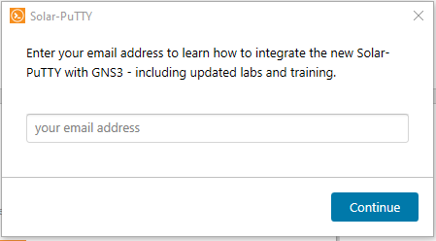

- The remaining software will be installed. Click Next when you see it says it was completed successfully.
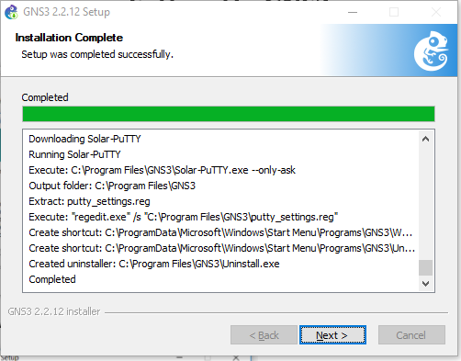
- At this point, you will be asked if you want to purchase SolarWinds to which you can answer no.
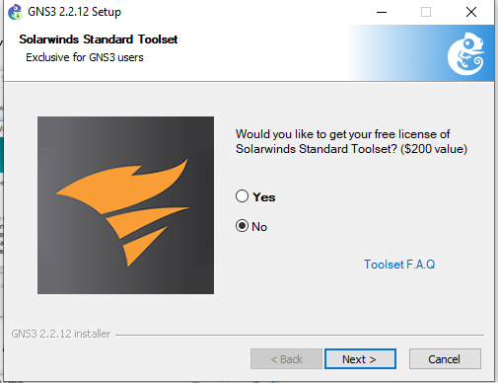
- Now your installation is completed, and click Finish to close the setup program and start GNS3.
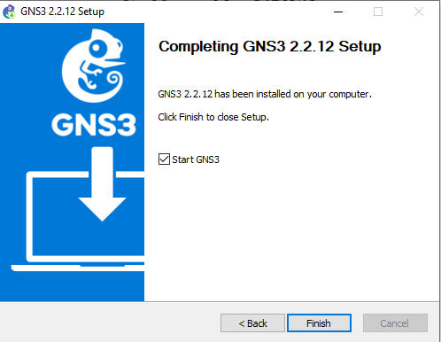
- When GNS3 Opens, select “Run appliances on my local computer”, then click Next.
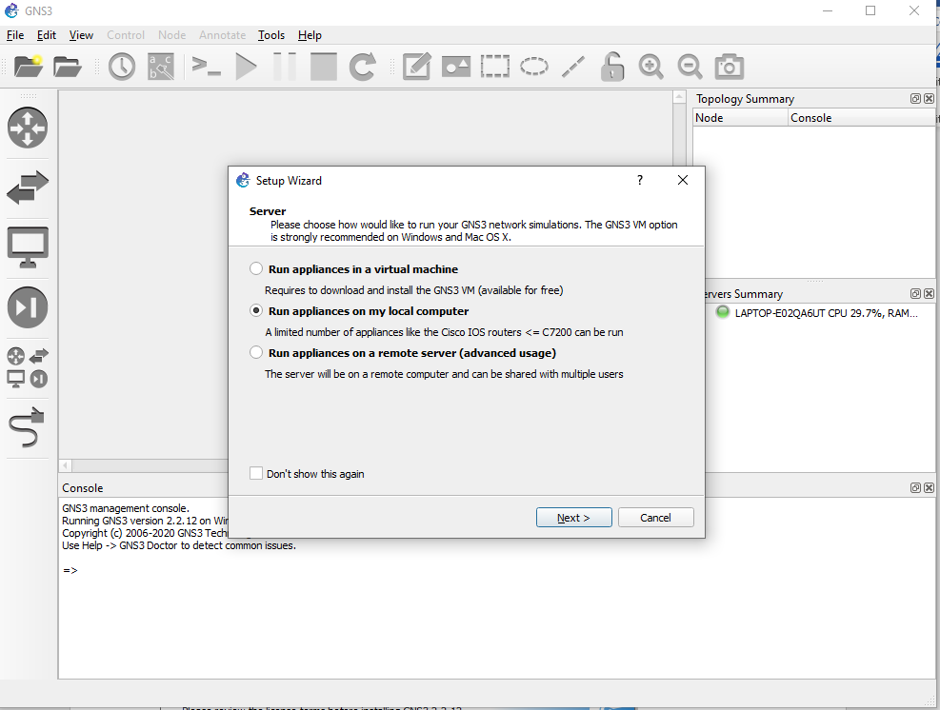

Select “Host Binding” as 127.0.0.1 or localhost. (This is the loopback IP on your local computer)
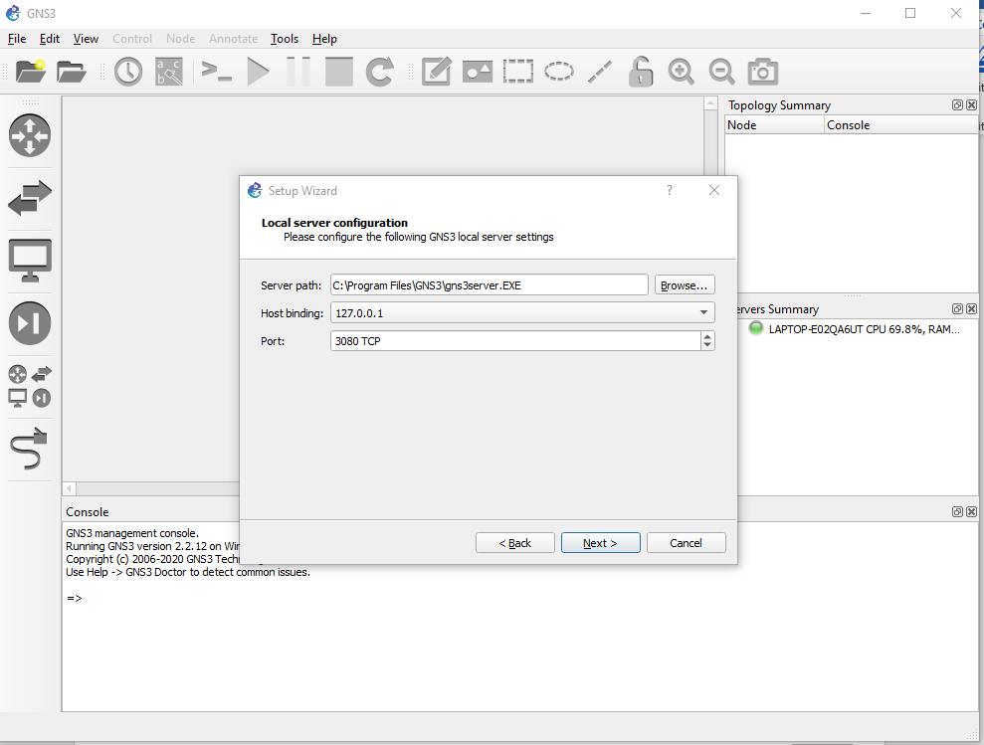

- You may get the following error message. If so, turn your firewall off, and retry.
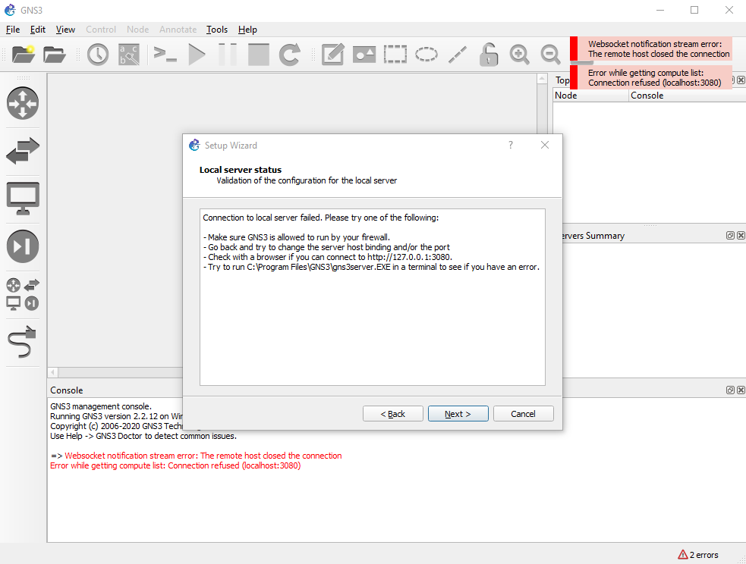
- Once you retry, it will prompt you to open a project. Mine is just called ‘untitled’.
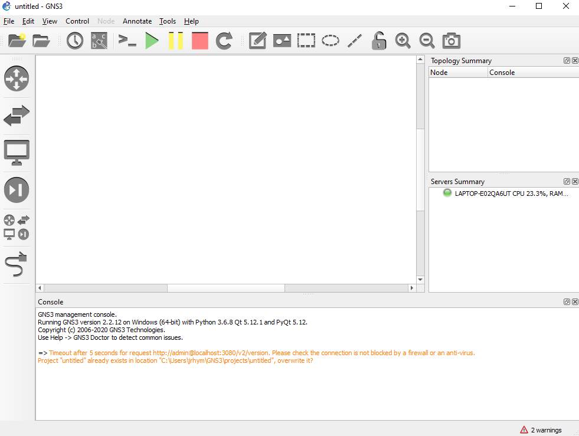
- Click on EditPreferences, then select Dynamips and IOS Routers. Click “new image” and browse the path for the downloaded IOS.
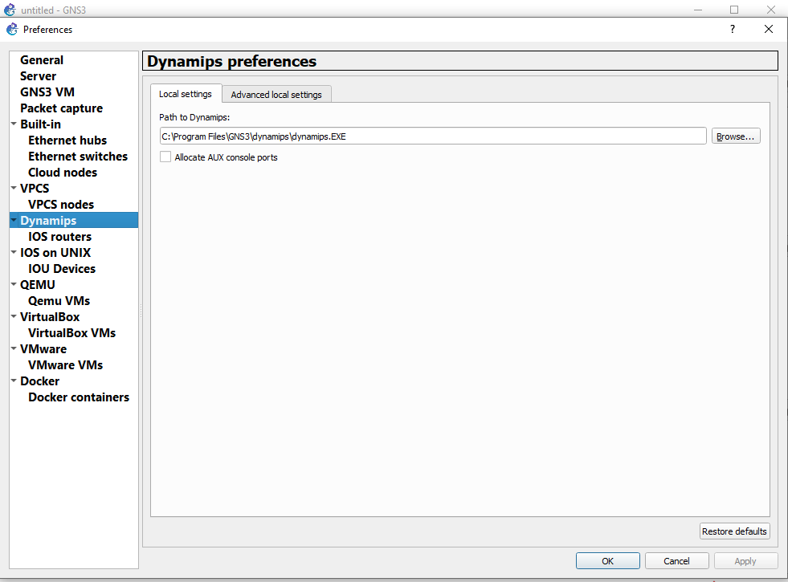
- Add the C7200 router, memory 512M, and interface module as shown below. Let it choose an idle PC value as well. 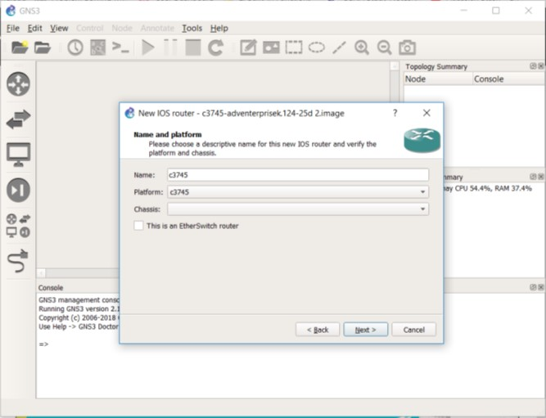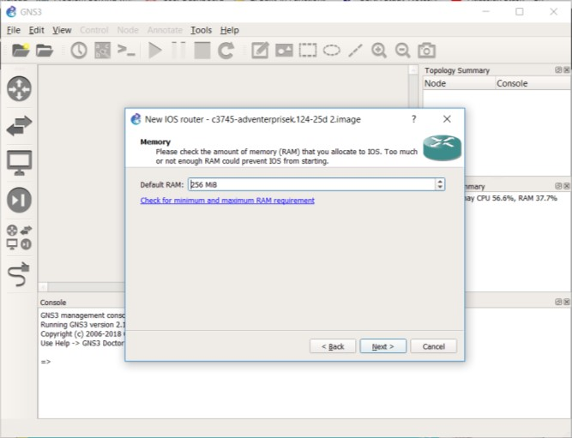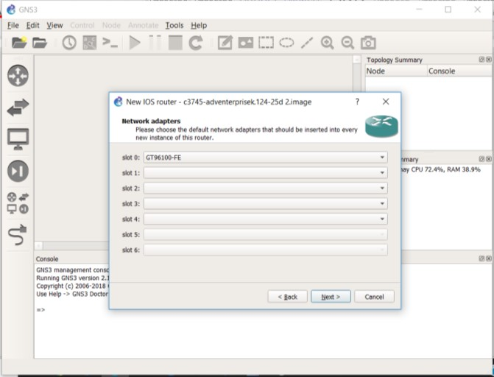

- Once built, we can use this same router for all of our routers in the topologies. You will need to add 2 Ethernet modules to get the ports we will need for this lab.

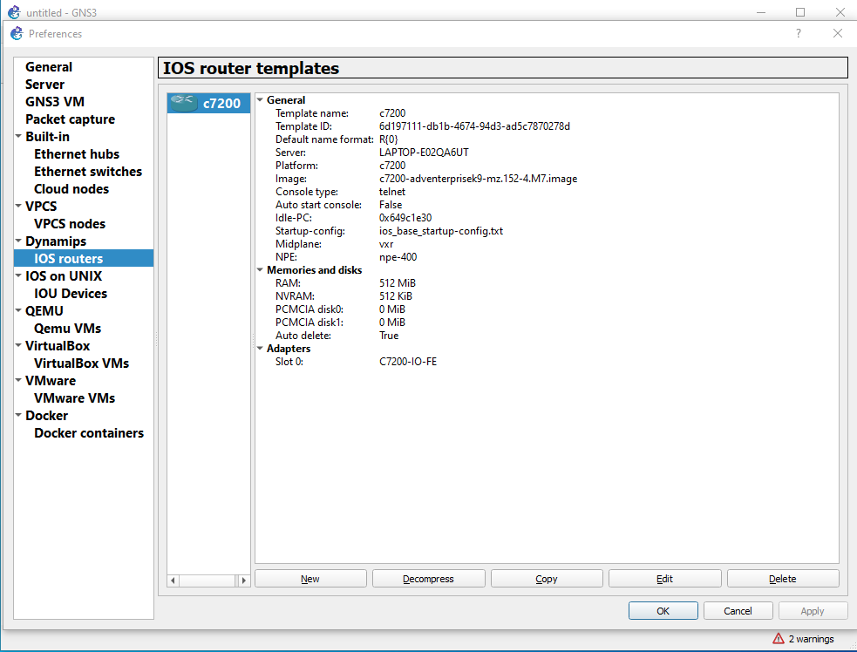
- You can now start building your lab topology by adding 7200 for R1 and R2, 2 PCs using the VPCs, and 2 Ethernet switches. You then can connect as shown below using the connector.
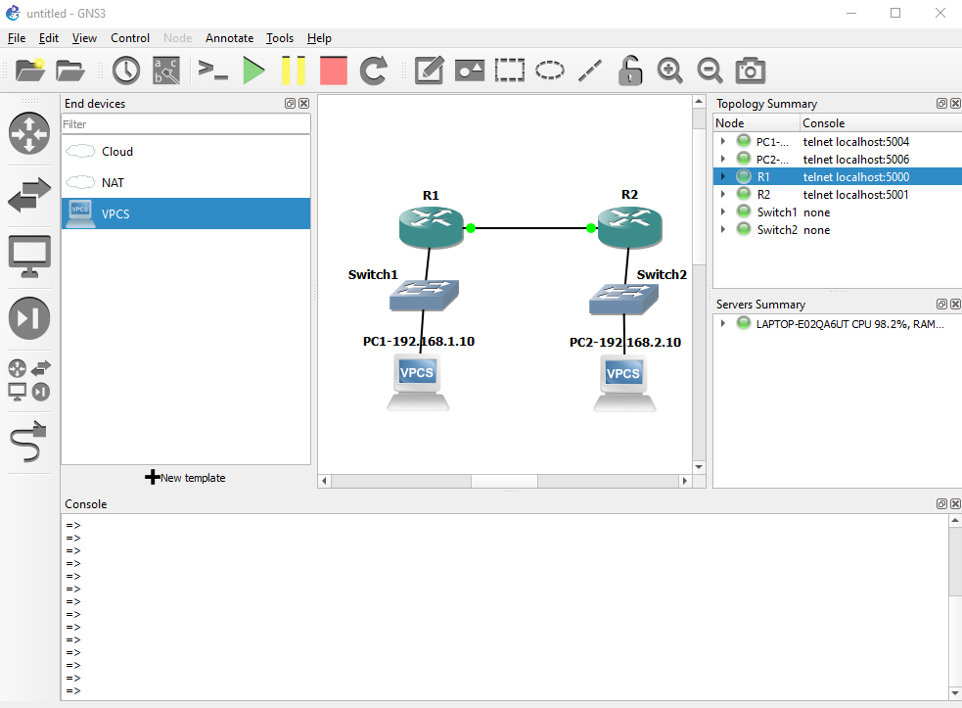

- We can configure this topology using 192.168.1.10 for PC1, 192.168.1.1 for R1-Fa0/0, 192.168.2.1 for R2-Fa0/0 and 192.168.2.10 for PC2. We can then configure 192.168.3.1 for R1-Fa1/0 and 192.168.3.2 for R2-Fa1/0. PC1 will use 192.168.1.1 as its gateway, and PC2 will use 192.168.2.1 for its gateway. We will run RIPv2 on both routers.
To configure, hit the green play button, and go into the console of each node PC1, R1, R2 and PC2. Below is what configuration goes into each.
PC1
Ip 192.168.1.10/24 192.168.1.1
R1
Conf t
Int fa0/0
Ip address 192.168.1.1 255.255.255.0
No shut
Int fa1/0
Ip address 192.168.3.1 255.255.255.0
No shut
Router rip
Version 2
Network 192.168.1.0
Network 192.168.3.0
R2
Conf t
Int fa0/0
Ip address 192.168.2.1 255.255.255.0
No shut
Int fa1/0
Ip address 192.168.3.2 255.255.255.0
No shut
Router rip
Version 2
Network 192.168.2.0
Network 192.168.3.0
PC2
Ip 192.168.2.10/24 192.168.2.1

- Issue a ping between PC1 and PC2 (ping 192.168.2.10 -t on PC1) and take a capture by right click on the link between the routers and selecting ‘Start Capture’.
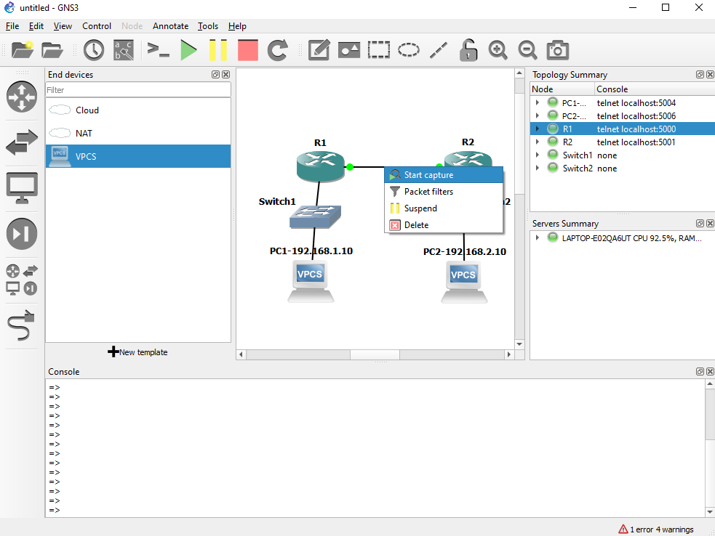
- You can then bring up the Wireshark and should see similar input. Take the applicable screenshots and hand it in.
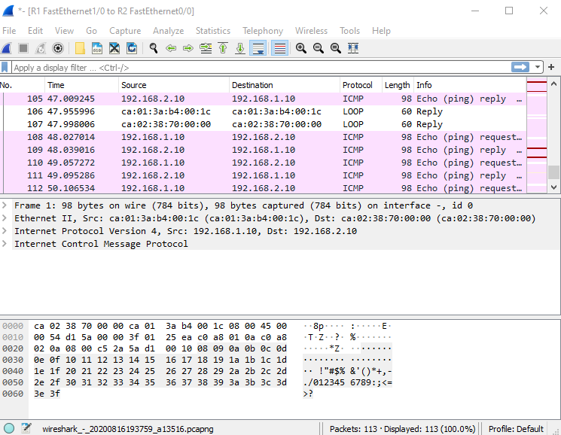

What to hand in
The goal of this lab was primarily to assure you completed the installation of both GNS3 and Wireshark. These will be used throughout the semester and in future courses.
The following questions will demonstrate that you have been able to get GNS3 and Wireshark installed and configured. Please follow the lab assignment format outlined on canvas and turn this in as a document in that format with the questions and applicable screenshots incorporated.

- Supply a screenshot of your GNS3 window with a simple topology as shown in step 25 above. You should save your project as “Lab 1-<SMU Student ID>. (where <SMU Student ID> is your student ID).
- Supply a screenshot of your Wireshark capture as shown above in Step 27, and save the PCAP as “Lab 1<Student ID> as well.
- What other traffic other than the ping do you see in the Wireshark Capture?
- What kinds of patterns do you see in the traffic? How much time passes between traffic types?
- Lab Report
Write a minimum of two type-written pages with a minimum of 12-point font describing what you learned in the lab. Do NOT simply repeat the steps you performed, summarize the purpose of the lab by explaining the concepts covered.
Your lab report will be submitted automatically to turnitin.com when you submit it to Canvas. You do not need to do anything besides submit the assignment to Canvas. Be sure you write your report in your own words.

